

Capstone Project Document

**FIRST AID**

**Report #2 – Software Requirement Specification**

|  |  |  |
| --- | --- | --- |
| **First Aid** | | |
| **Group Members** | Đàm Huy Hùng | SE03431 |
| Nguyễn Duy Anh | 01525 |
| Mai Trung Kiên | SE02994 |
| Nguyễn Tiến Dũng | SE03272 |
| Nguyễn Phúc An | SE03118 |
| **Supervisor** | Mr. Nguyễn Văn Sang | |
| **Project code** | FAVN | |

**- Hanoi, 09/2016 -**

# **SIGNATURE PAGE**

AUTHOR: Nguyễn Duy Anh 00/09/2016

Team member

REVIEWERS: Đàm Huy Hùng 00/09/2016

Project Manager

APPROVAL: Nguyễn Văn Sang --/--/--16

Supervisor

Record of change

*A - Added M - Modified D – Deleted

|  |  |  |  |  |  |
| --- | --- | --- | --- | --- | --- |
| Effective Date | Changed Item | A,M,D | Change Description | Reason for Change | Rev. Number |
| 01/10/2015 | Create Software Requirements Specifications | A | First version | Create Software Requirements Specifications | 1.0 |
| 02/10/2015 | Modify Business rule, Non-Functional specification | M | First version | Modify Software Requirements Specifications | 1.1 |
| 09/12/2015 | Modify Use case | M | First version | Modify Software Requirements Specifications | 1.2 |
|  |  |  |  |  |  |
|  |  |  |  |  |  |
|  |  |  |  |  |  |

**TABLE CONTENTS**

**SIGNATURE PAGE 2**

**1. INTRODUCTION 4**

1.1. Purpose 4

1.2. Definitions and Acronyms 4

1.3. System Purpose 5

**2.** **OVERALL DESCRIPTION 5**

2.1. System overview 5

2.2. Use Case Diagram 7

2.3. Product Features 7

2.3.1. User Characteristics 9

2.3.2. User Documentation 10

2.3.3. Assumption 10

2.4. Entity Relation Model 10

2.4.1. Entity-Relationship Diagram 10

2.4.2. Entity Detail 11

**3.** **FUNCTIONAL SPECIFICATION** 14

3.1. Business Rules 14

3.2. Use Cases 16

3.2.1. Guest/ Registered Group Function 16

3.2.2. Guest Group Function 36

3.2.3. Registered Group Function 38

3.2.4. Administrator Group Function 54

**4.** **NON-FUNCTIONAL SPECIFICATION** 96

4.1. Reliability 96

4.2. Performance Requirements 96

4.2.1. Availability 96

4.2.2. Response time 96

4.2.3. Maintainability 96

4.2.4. Usability 97

4.2.5. Security Requirements 97

4.2.6. Hardware/Software Requirements 97

# **INTRODUCTION**

## **Purpose**

This document is created as the introduction for project First Aid – our Capstone Project at FPT University. In this document, we provide the describing of general requirement and non-functional requirements. These requirements will ensure that the system will correctly and reliably perform its intended functionality. This specification will provide general, as well as specific requirements to be used in the design, testing and validation of the system. It is intended for both stakeholders and the project team of the system.

## **Definitions and Acronyms**

|  |  |  |
| --- | --- | --- |
| **Acronym** | **Definition** | **Note** |
| FAS | First Aid system |  |
| FAA | First Aid application |  |
| SRS | Software Requirements Specifications |  |
| Admin | FAS’s administrator |  |

Table 2-1: Definition and Acronyms

## **System Purpose**

For the purpose of offering Vietnamese people effective methods in emergencies, as well as help the community better understand what is aid and the importance of first aid, we implement a project to develop an application that can be like an assistance for users, called First Aid. In First Aid application, we can solve the limitations of hard copy documents and other products. Besides, we provide first aid’s step-by-step instructions to make sure that even untrained people can understand and follow. In addition, users can make SOS calling and find nearby hospitals and other useful features for life saving.

# **OVERALL DESCRIPTION**

## **System overview**

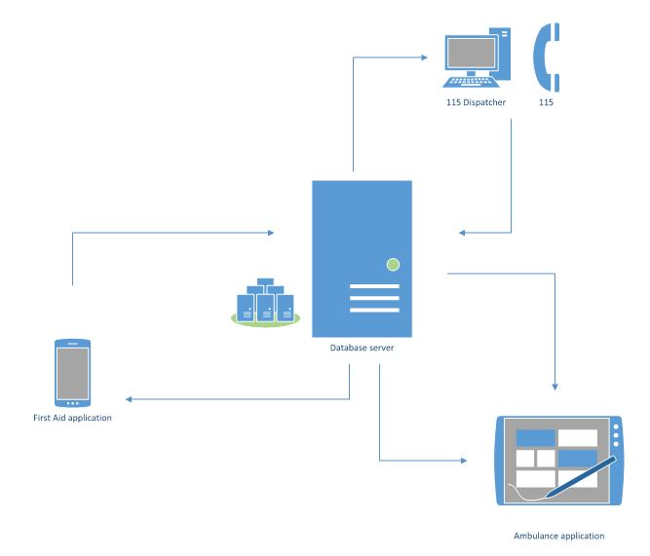

Figure 2-1: System Overview

## **Product Features**

### **First Aid Application**

|  |  |  |  |
| --- | --- | --- | --- |
| UC No. | Group Of Functions | Function | Glossary |
| First Aid Application | | | |
|  | Emergency | View list of injuries |  |
|  | View instruction steps of injury |  |
|  | Search injuries |  |
|  | Call 115 |  |
|  | Speak instruction steps |  |
|  | View current location |  |
|  | View list of nearest health facilities |  |
|  | Show direction to health facility |  |
|  | Call to health facility |  |
|  | Learning | View list of learning injuries |  |
|  | View learning instruction steps |  |
|  | View FAQs |  |
|  | More | Send questions |  |
|  | View courses |  |
|  | Share application |  |
|  | Setting | Allow to send information |  |
|  | Information | View application information |  |

Table 2-2-1: List of use cases

### **Dispatcher Application**

|  |  |  |  |  |
| --- | --- | --- | --- | --- |
| UC No. | Group Of Functions | Function | Glossary | |
| Dispatcher Application | | | | |
|  | Common | Login | |  |
|  | Logout | |  |
|  | Dispatch | Create emergency case | |  |
|  | Dispatch ambulance | |  |
|  | View ambulance information | |  |
|  | View caller information | |  |
|  | Show direction from ambulance to caller | |  |
|  | View list of callers | |  |
|  | Notify ambulances status | |  |
|  | Cancel emergency case | |  |

Table 2-2-2: List of use cases

### **Ambulance Application**

|  |  |  |  |  |  |
| --- | --- | --- | --- | --- | --- |
| UC No. | Group Of Functions | | Function | Glossary | |
| Ambulance Application | | | | | |
|  | Common | Login | | |  |
|  | Logout | | |  |
|  | Task | View ambulance team information | | |  |
|  | Accept/Decline task | | |  |
|  | Show location of caller | | |  |
|  | Show direction to caller | | |  |
|  | Report picked up caller | | |  |
|  | Report completed task | | |  |
|  | Report problem | | |  |
|  | Change status | | |  |

Table 2-2-3: List of use cases

### **Admin/Expert Application**

|  |  |  |  |  |  |
| --- | --- | --- | --- | --- | --- |
| UC No. | Group Of Functions | | Function | | Glossary |
| Admin/Expert Application | | | | | |
|  | Common | Login | |  | |
|  | Logout | |  | |
|  | Manage user's account | Create account | |  | |
|  | View list of users | |  | |
|  | Search user's account | |  | |
|  | Update user’s account | |  | |
|  | Delete user’s account | |  | |
|  | Manage Q&A | View user’s question | |  | |
|  | View answer | |  | |
|  | Answer question | |  | |
|  | Delete question | |  | |
|  | Manage injury | Add new injury | |  | |
|  | View list of injuries | |  | |
|  | Search injury | |  | |
|  | Update injury | |  | |
|  | Delete injury | |  | |

Table 2-2-4: List of use cases

## **User Characteristics**

FAS has five objective users:

* **FAA user:** Users uses First Aid application in android mobile.
* **Dispatcher:** Users are offered an account by admin to use Dispatcher website.
* **Ambulance staff:** Users are offered an account by admin to use Ambulance application in tablet.
* **Expert:** Users are offered an account by admin to use First Aid website, they can manage all information about first aid and learning of emergencies, answer the question of FAA users.
* **Admin:** They can manage all information about all user types, answer the question of FAA users.

## **User Documentation**

|  |  |
| --- | --- |
| Name | Description |
| User Guide | Provide detailed explanation about the system, screens and guide users how to use all features of First Aid System. |

Table 2-3: User Documentation

## **Assumption**

* Receive the guidance and good support of teacher.
* No one of member got sick in the software development process.
* In the development process, no device got fail.
* Every report, task meets the deadline.
* Team member do not conflict in the work process.

## **Entity Relation Model**

### **Entity-Relationship Diagram**

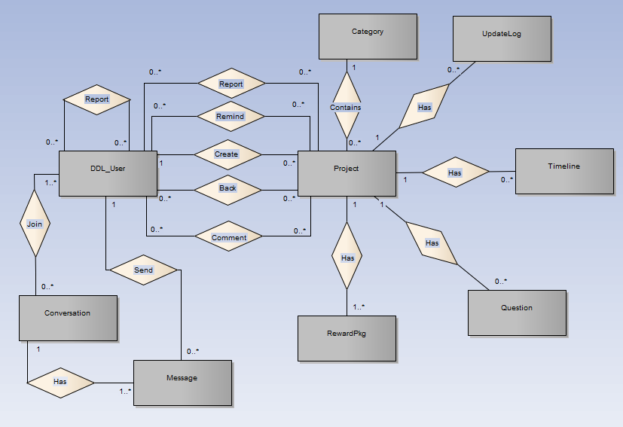

**Figure 2-3:** Entity Relationship Diagram

### **Entity Detail**

#### DDL_User

|  |  |  |  |  |
| --- | --- | --- | --- | --- |
| No | Attribute | Type | Mandatory | Description |
|  | UserID | Int | Y | User’s ID |
|  | UserName | String | Y | User’s name |
|  | Password | String | Y | User’s password |
|  | IsActive | Boolean | Y | User’s active status (inactive, active) |
|  | CreatedDate | Date | Y | User’s created date |
|  | LoginType | String | Y | User’s created type includes: normal, Facebook or both |
|  | LastLogin | Date | Y | User’s last login |
|  | UserType | String | Y | User’s type (admin or normal user) |
|  | IsVerify | Boolean | Y | User’ email verify status |
|  | VerifyCode | String | Y | User’s verify code |
|  | Email | String | Y | User’s email |

Table 2-4: DDL-User

#### Project

|  |  |  |  |  |
| --- | --- | --- | --- | --- |
| No | Attribute | Type | Mandatory | Description |
|  | ProjectID | Int | Y | Project’s ID |
|  | ProjectCode | String | Y | Project’s code with fixed format |
|  | CategoryID | Int | Y | Project’s category |
|  | UserID | Int | Y | Project’s UserID who created project |
|  | ProjectTitle | String | Y | Project’s title |
|  | Risk | String | Y | Project’s risk |
|  | ImageLink | String | Y | Project’s image link |
|  | SubDescription | String | Y | Project’s sub description |
|  | Location | String | Y | Project’s location created |
|  | IsExpired | Boolean | Y | Is Project’s expired |
|  | CurrentFunded | Decimal | Y | Project’s funded status |
|  | IsFunded | Boolean | Y | Is Project’s funded |
|  | CreatedDate | Date | Y | Project’s created date |
|  | ExpiredDate | Date | Y | Project’s expired date |
|  | FundingGoal | Decimal | Y | Project’s funding goal |
|  | Description | String | Y | Project’s description |
|  | LinkVideo | String | Y | Project’s video link |
|  | Story | String | Y | Project’s story |
|  | PopularPoint | Int | Y | Project’s popular point |
|  | Status | String | Y | Project’s status ( draft, pending, approved, suspended) |
|  | UpdatedDate | Date |  | Project’s updatedDate |

Table 2-5: Project

#### Category

|  |  |  |  |  |
| --- | --- | --- | --- | --- |
| No | Attribute | Type | Mandatory | Description |
| 1. 1 | CategoryID | Int | Y | Category’s ID |
| 1. 2 | Name | String | Y | Category’s name |
| 1. 3 | IsActive | Boolean | Y | Category’s active status |
|  | Description | String | Y | Category’s description |

Table 2-6: Category

#### UpdateLog table

|  |  |  |  |  |
| --- | --- | --- | --- | --- |
| No | Attribute | Type | Mandatory | Description |
| 1. 1 | UpdateID | Int | Y | Update’s ID |
| 1. 2 | ProjectID | Int | Y | Update’s project id |
| 1. 3 | Title | String | Y | Update’s title |
|  | Description | String | Y | Update’s description |
|  | CreatedDate | Date | Y | Update’s createdDate |

Table 2-7: UpdateLog table

#### Timeline table

|  |  |  |  |  |
| --- | --- | --- | --- | --- |
| No | Attribute | Type | Mandatory | Description |
| 1. 1 | TimelineID | Int | Y | Timeline’s ID |
| 1. 2 | ProjectID | Int | Y | Timeline’s project id |
| 1. 3 | Title | String | Y | Timeline’s title |
|  | Description | String | Y | Timeline’s description |
|  | DueDate | Date | Y | Timeline’s due date |
|  | ImageUrl | String | Y | Timeline’s Image Url |

Table 2-8: Timeline table

#### Question table

|  |  |  |  |  |
| --- | --- | --- | --- | --- |
| No | Attribute | Type | Mandatory | Description |
| 1. 1 | QuestionID | Number | Y | Question and answer’s ID |
| 1. 2 | ProjectID | Number | Y | Question and answer’s project id |
| 1. 3 | Question | String | Y | Question and answer’s question |
|  | Answer | String | Y | Question and answer’s answer |
|  | CreatedDate | Date | Y | Question and answer’s created date |

Table 2-9: Caption table

#### Reward package table

|  |  |  |  |  |
| --- | --- | --- | --- | --- |
| No | Attribute | Type | Mandatory | Description |
| 1. 1 | RewardID | Int | Y | Reward’s ID |
| 1. 2 | ProjectID | Int | Y | Reward’s project id |
| 1. 3 | LimitedQuantity | String | Y | Reward’s limited quantity |
|  | Type | String | Y | Reward’s type |
|  | Description | String | Y | Reward’s description |
|  | EstimatedDeliveryDate | Date | Y | Reward’s estimated delivery date |
|  | IsHide | Boolean | Y | Is Reward hide |
|  | CurrentQuantity | int | Y | Reward’s current quantity |
|  | PledgeAmount | Decimal | Y | Reward’s PledgeAmount |

Table 2-10: Reward package table

#### Message table

|  |  |  |  |  |
| --- | --- | --- | --- | --- |
| No | Attribute | Type | Mandatory | Description |
| 1. 1 | MessageID | Number | Y | Message’s ID |
| 1. 2 | ConversationID | Number | Y | Message’s conversation id |
| 1. 3 | UserID | Number | Y | Message’s user id |
|  | MessageContent | String | Y | Message’s content |
|  | SentTime | Date | Y | Message’s sent time |

Table 2-11: Message table

#### Conversation table

|  |  |  |  |  |
| --- | --- | --- | --- | --- |
| No | Attribute | Type | Mandatory | Description |
|  | ConversationID | Number | Y | Conversation’s ID |
|  | CreatorID | Number | Y | Conversation’s creator id |
|  | ReceiverID | Number | Y | Conversation’s receiver |
|  | Subject | String | Y | Conversation’s subject |
|  | CreatedDate | Date | Y | Conversation’s created date |
|  | UpdatedDate | Date | Y | Conversation’s update date |
|  | DeleteStatus | String | Y | Conversation’s user delete status |
|  | ViewStatus | String | Y | Conversation’s user view status |

Table 2-12: Conversation table

# **FUNCTIONAL SPECIFICATION**

## **Business Rules**

|  |  |
| --- | --- |
| **No** | **Description** |
|  |  |
|  |  |
|  |  |
|  |  |
|  |  |
|  |  |
|  |  |
|  |  |
|  |  |
|  |  |
|  |  |
|  |  |
|  |  |
|  |  |
|  |  |
|  |  |
|  |  |
|  |  |

Table 2-13: Business rules

## **Use Cases**

### **First Aid Application Function**

#### Emergencies Module

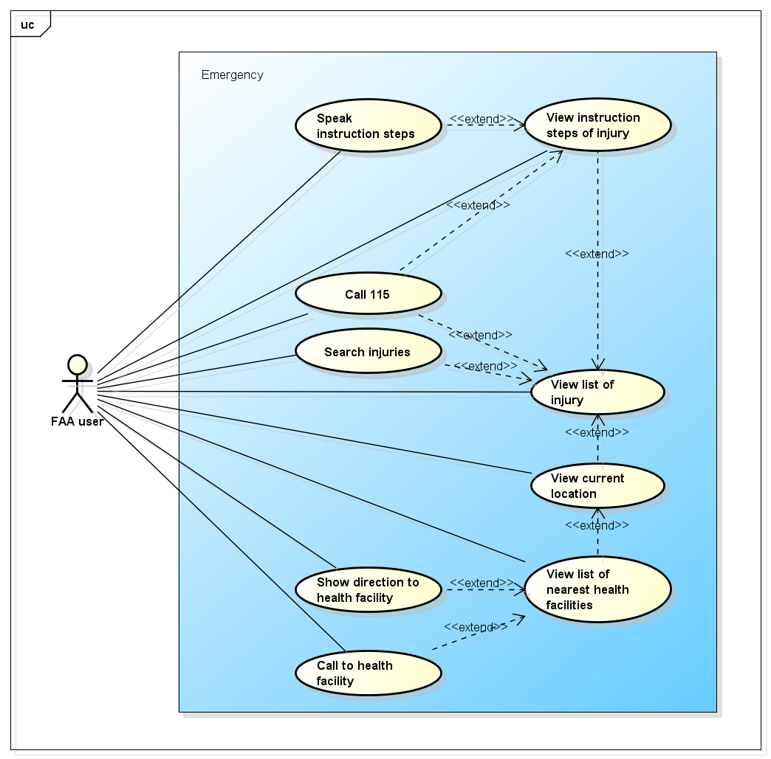

Figure -4: Emergencies use case

##### UC001 - View list of injury

|  |  |  |  |  |
| --- | --- | --- | --- | --- |
| **Use Case ID** | | UC001 | **Version** | 1.1 |
| **Use Case Name** | | View list of injury | | |
| **Created by:** | | AnhND | **Date Created:** | 24/09/2016 |
| **Primary Actor** | | FAA user | **Secondary Actor** |  |
| **Description:** | | This function allows user to view all emergencies need to first aid in First Aid application. | | |
| **Preconditions:** | | Install First Aid application | | |
| **Trigger:** | | User launch application | | |
| **Post conditions:** | | All existing emergencies will be displayed in the mobile screen. | | |
| **Normal Flow** | | | | |
| **Step** | **Actor** | **Action** | | |
| 1 | Customer | Launch application | | |
| 2 | FAA | List all existing emergencies | | |
| **Alternative Flows: N/A** | | | | |
| **Exceptions: N/A** | | | | |
| **Priority** | | High | | |
| **Frequency of Use:** | | High | | |
| **Business Rules:** | |  | | |
| **Other Information:** | | N/A | | |

Table 2- 4: View list of injury

##### UC002 - View instruction steps of injury

|  |  |  |  |  |
| --- | --- | --- | --- | --- |
| **Use Case ID** | | UC002 | **Version** | 1.1 |
| **Use Case Name** | | View instruction steps of injury | | |
| **Created by:** | | AnhND | **Date Created:** | 24/09/2016 |
| **Primary Actor** | | FAA user | **Secondary Actor** |  |
| **Description:** | | This function allows user to view first aid step instructions of an emergency. | | |
| **Preconditions:** | | 1. Install First Aid application 2. Customer launch application | | |
| **Trigger:** | | User taps on an emergency in the list emergencies that displayed in the mobile screen. | | |
| **Post conditions:** | | All first aid step instructions about this emergency will be displayed in the mobile screen. | | |
| **Normal Flow** | | | | |
| **Step** | **Actor** | **Action** | | |
| 1 | Customer | Launch application | | |
| 2 | Customer | Tap on an emergency in the list | | |
| 3 | FAA | Show all first aid step instructions | | |
| **Alternative Flows:** | | | | |
| **AT1** | At step 2 in the main flows, if user taps on other buttons. | | | |
| **Step** | **Actor** | **Action** | | |
| 2.1 | FAA | Redirects user to chosen button. | | |
| **Exceptions: N/A** | | | | |
| **Priority** | | High | | |
| **Frequency of Use:** | | High | | |
| **Business Rules:** | |  | | |
| **Other Information:** | | N/A | | |

Table 2- 4: View instruction steps of injury

##### UC003 - Search injuries

|  |  |  |  |  |
| --- | --- | --- | --- | --- |
| **Use Case ID** | | UC003 | **Version** | 1.1 |
| **Use Case Name** | | Search injuries | | |
| **Created by:** | | AnhND | **Date Created:** | 24/09/2016 |
| **Primary Actor** | | FAA user | **Secondary Actor** |  |
| **Description:** | | This function allows user to search an emergency exits on FAA by text | | |
| **Preconditions:** | | 1. Install First Aid application 2. Customer launch application | | |
| **Trigger:** | | User taps on search button, enters search phrase and taps Search | | |
| **Post conditions:** | | All results that matched with the keyword user enters will be displayed in the mobile screen. | | |
| **Normal Flow** | | | | |
| **Step** | **Actor** | **Action** | | |
| 1 | Customer | Tap on search button | | |
| 2 | Customer | Enter search phrase to text box | | |
| 3 | Customer | Tap Search | | |
| 4 | DDL | List all results that matched with the keyword user entered | | |
| **Alternative Flows:** | | | | |
| **AT1** | At step 2 in the main flows, if user taps on an emergency in the list under the text box. | | | |
| **Step** | **Actor** | **Action** | | |
| 2.1 | FAA | Redirects user to first aid step instructions of chosen emergency. | | |
|  | | | | |
| **AT2** | At step 2 in the main flows, if user taps on back button. | | | |
| **Step** | **Actor** | **Action** | | |
| 2.1 | FAA | Redirects user to emergencies screen | | |
|  | | | | |
| **AT3** | At step 3 in the main flows, if user taps on [x] button | | | |
| **Step** | **Actor** | **Action** | | |
| 3.1 | FAA | Redirects user to text box to enters search phrase | | |
| **Exceptions: N/A** | | | | |
| **Priority** | | High | | |
| **Frequency of Use:** | | High | | |
| **Business Rules:** | |  | | |
| **Other Information:** | | N/A | | |

Table 2- 15: Search injuries

##### UC004 - Call 115

|  |  |  |  |  |
| --- | --- | --- | --- | --- |
| **Use Case ID** | | UC004 | **Version** | 1.1 |
| **Use Case Name** | | Call 115 | | |
| **Created by:** | | AnhND | **Date Created:** | 24/09/2016 |
| **Primary Actor** | | FAA user | **Secondary Actor** |  |
| **Description:** | | This function allows user to make emergency calls to the 115 center. | | |
| **Preconditions:** | | 1. Install First Aid application 2. Customer launch application | | |
| **Trigger:** | |  | | |
| **Post conditions:** | |  | | |
| **Normal Flow** | | | | |
| **Step** | **Actor** | **Action** | | |
| 1 | Customer | Launch application | | |
| 2 | Customer |  | | |
| 3 | FAA |  | | |
| **Alternative Flows:** | | | | |
| **AT1** |  | | | |
| **Step** | **Actor** | **Action** | | |
|  |  |  | | |
| **Exceptions: N/A** | | | | |
| **Priority** | | High | | |
| **Frequency of Use:** | | High | | |
| **Business Rules:** | |  | | |
| **Other Information:** | | N/A | | |

Table 2- 15: Call 115

##### UC005 - Speak instruction steps

|  |  |  |  |  |
| --- | --- | --- | --- | --- |
| **Use Case ID** | | UC005 | **Version** | 1.1 |
| **Use Case Name** | | Speak instruction steps | | |
| **Created by:** | | AnhND | **Date Created:** | 24/09/2016 |
| **Primary Actor** | | FAA user | **Secondary Actor** |  |
| **Description:** | |  | | |
| **Preconditions:** | | 1. Install First Aid application 2. Customer launch application | | |
| **Trigger:** | |  | | |
| **Post conditions:** | |  | | |
| **Normal Flow** | | | | |
| **Step** | **Actor** | **Action** | | |
| 1 | Customer | Launch application | | |
| 2 | Customer |  | | |
| 3 | FAA |  | | |
| **Alternative Flows:** | | | | |
| **AT1** |  | | | |
| **Step** | **Actor** | **Action** | | |
|  |  |  | | |
| **Exceptions: N/A** | | | | |
| **Priority** | | High | | |
| **Frequency of Use:** | | High | | |
| **Business Rules:** | |  | | |
| **Other Information:** | | N/A | | |

Table 2- 15: Speak instruction steps

##### UC006 - View current location

|  |  |  |  |  |
| --- | --- | --- | --- | --- |
| **Use Case ID** | | UC006 | **Version** | 1.1 |
| **Use Case Name** | | View current location | | |
| **Created by:** | | AnhND | **Date Created:** | 24/09/2016 |
| **Primary Actor** | | FAA user | **Secondary Actor** |  |
| **Description:** | | This function allows user to locate their current location correctly. | | |
| **Preconditions:** | | 1. Install First Aid application 2. Customer launch application | | |
| **Trigger:** | |  | | |
| **Post conditions:** | |  | | |
| **Normal Flow** | | | | |
| **Step** | **Actor** | **Action** | | |
| 1 | Customer | Launch application | | |
| 2 | Customer |  | | |
| 3 | FAA |  | | |
| **Alternative Flows:** | | | | |
| **AT1** |  | | | |
| **Step** | **Actor** | **Action** | | |
|  |  |  | | |
| **Exceptions: N/A** | | | | |
| **Priority** | | High | | |
| **Frequency of Use:** | | High | | |
| **Business Rules:** | |  | | |
| **Other Information:** | | N/A | | |

Table 2- 15: View current location

##### UC007 - View list of nearest health facilities

|  |  |  |  |  |
| --- | --- | --- | --- | --- |
| **Use Case ID** | | UC007 | **Version** | 1.1 |
| **Use Case Name** | | View list of nearest health facilities | | |
| **Created by:** | | AnhND | **Date Created:** | 24/09/2016 |
| **Primary Actor** | | FAA user | **Secondary Actor** |  |
| **Description:** | | This function allows user to view nearest hospital list from their location. | | |
| **Preconditions:** | | 1. Install First Aid application 2. Customer launch application | | |
| **Trigger:** | |  | | |
| **Post conditions:** | |  | | |
| **Normal Flow** | | | | |
| **Step** | **Actor** | **Action** | | |
| 1 | Customer | Launch application | | |
| 2 | Customer |  | | |
| 3 | FAA |  | | |
| **Alternative Flows:** | | | | |
| **AT1** |  | | | |
| **Step** | **Actor** | **Action** | | |
|  |  |  | | |
| **Exceptions: N/A** | | | | |
| **Priority** | | High | | |
| **Frequency of Use:** | | High | | |
| **Business Rules:** | |  | | |
| **Other Information:** | | N/A | | |

Table 2- 15: View list of nearest health facilities

##### UC008 - Show direction to health facility

|  |  |  |  |  |
| --- | --- | --- | --- | --- |
| **Use Case ID** | | UC008 | **Version** | 1.1 |
| **Use Case Name** | | Show direction to health facility | | |
| **Created by:** | | AnhND | **Date Created:** | 24/09/2016 |
| **Primary Actor** | | FAA user | **Secondary Actor** |  |
| **Description:** | |  | | |
| **Preconditions:** | | 1. Install First Aid application 2. Customer launch application | | |
| **Trigger:** | |  | | |
| **Post conditions:** | |  | | |
| **Normal Flow** | | | | |
| **Step** | **Actor** | **Action** | | |
| 1 | Customer | Launch application | | |
| 2 | Customer |  | | |
| 3 | FAA |  | | |
| **Alternative Flows:** | | | | |
| **AT1** |  | | | |
| **Step** | **Actor** | **Action** | | |
|  |  |  | | |
| **Exceptions: N/A** | | | | |
| **Priority** | | High | | |
| **Frequency of Use:** | | High | | |
| **Business Rules:** | |  | | |
| **Other Information:** | | N/A | | |

Table 2- 15: Show direction to health facility

##### UC009 - Call to health facility

|  |  |  |  |  |
| --- | --- | --- | --- | --- |
| **Use Case ID** | | UC009 | **Version** | 1.1 |
| **Use Case Name** | | Call to health facility | | |
| **Created by:** | | AnhND | **Date Created:** | 24/09/2016 |
| **Primary Actor** | | FAA user | **Secondary Actor** |  |
| **Description:** | | This function allows user to call to the hospital | | |
| **Preconditions:** | | 1. Install First Aid application 2. Customer launch application | | |
| **Trigger:** | |  | | |
| **Post conditions:** | |  | | |
| **Normal Flow** | | | | |
| **Step** | **Actor** | **Action** | | |
| 1 | Customer | Launch application | | |
| 2 | Customer |  | | |
| 3 | FAA |  | | |
| **Alternative Flows:** | | | | |
| **AT1** |  | | | |
| **Step** | **Actor** | **Action** | | |
|  |  |  | | |
| **Exceptions: N/A** | | | | |
| **Priority** | | High | | |
| **Frequency of Use:** | | High | | |
| **Business Rules:** | |  | | |
| **Other Information:** | | N/A | | |

Table 2- 15: Call to health facility

#### Learning Module

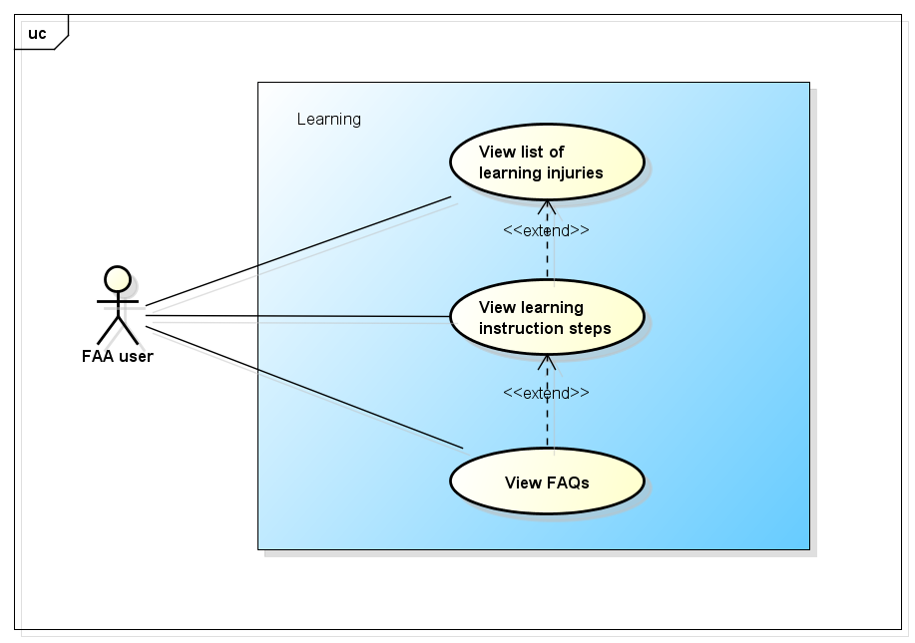

Figure -5: Learning use case

##### UC0010 - View list of learning injuries

|  |  |  |  |  |
| --- | --- | --- | --- | --- |
| **Use Case ID** | | UC0010 | **Version** | 1.1 |
| **Use Case Name** | |  | | |
| **Created by:** | | AnhND | **Date Created:** | 24/09/2016 |
| **Primary Actor** | | FAA user | **Secondary Actor** |  |
| **Description:** | |  | | |
| **Preconditions:** | | 1. Install First Aid application 2. Customer launch application | | |
| **Trigger:** | |  | | |
| **Post conditions:** | |  | | |
| **Normal Flow** | | | | |
| **Step** | **Actor** | **Action** | | |
| 1 | Customer | Launch application | | |
| 2 | Customer |  | | |
| 3 | FAA |  | | |
| **Alternative Flows:** | | | | |
| **AT1** |  | | | |
| **Step** | **Actor** | **Action** | | |
|  |  |  | | |
| **Exceptions: N/A** | | | | |
| **Priority** | | High | | |
| **Frequency of Use:** | | High | | |
| **Business Rules:** | |  | | |
| **Other Information:** | | N/A | | |

Table 2- 15: View list of learning injuries

##### UC0011 - View learning instruction steps

|  |  |  |  |  |
| --- | --- | --- | --- | --- |
| **Use Case ID** | | UC0011 | **Version** | 1.1 |
| **Use Case Name** | |  | | |
| **Created by:** | | AnhND | **Date Created:** | 24/09/2016 |
| **Primary Actor** | | FAA user | **Secondary Actor** |  |
| **Description:** | |  | | |
| **Preconditions:** | | 1. Install First Aid application 2. Customer launch application | | |
| **Trigger:** | |  | | |
| **Post conditions:** | |  | | |
| **Normal Flow** | | | | |
| **Step** | **Actor** | **Action** | | |
| 1 | Customer | Launch application | | |
| 2 | Customer |  | | |
| 3 | FAA |  | | |
| **Alternative Flows:** | | | | |
| **AT1** |  | | | |
| **Step** | **Actor** | **Action** | | |
|  |  |  | | |
| **Exceptions: N/A** | | | | |
| **Priority** | | High | | |
| **Frequency of Use:** | | High | | |
| **Business Rules:** | |  | | |
| **Other Information:** | | N/A | | |

Table 2- 17: View learning instruction steps

##### UC0012 - View FAQs

|  |  |  |  |  |
| --- | --- | --- | --- | --- |
| **Use Case ID** | | UC0012 | **Version** | 1.1 |
| **Use Case Name** | | View FAQs | | |
| **Created by:** | | AnhND | **Date Created:** | 24/09/2016 |
| **Primary Actor** | | FAA user | **Secondary Actor** |  |
| **Description:** | |  | | |
| **Preconditions:** | | 1. Install First Aid application 2. Customer launch application | | |
| **Trigger:** | |  | | |
| **Post conditions:** | |  | | |
| **Normal Flow** | | | | |
| **Step** | **Actor** | **Action** | | |
| 1 | Customer | Launch application | | |
| 2 | Customer |  | | |
| 3 | FAA |  | | |
| **Alternative Flows:** | | | | |
| **AT1** |  | | | |
| **Step** | **Actor** | **Action** | | |
|  |  |  | | |
| **Exceptions: N/A** | | | | |
| **Priority** | | High | | |
| **Frequency of Use:** | | High | | |
| **Business Rules:** | |  | | |
| **Other Information:** | | N/A | | |

Table 2- 18: View FAQs

#### More Module

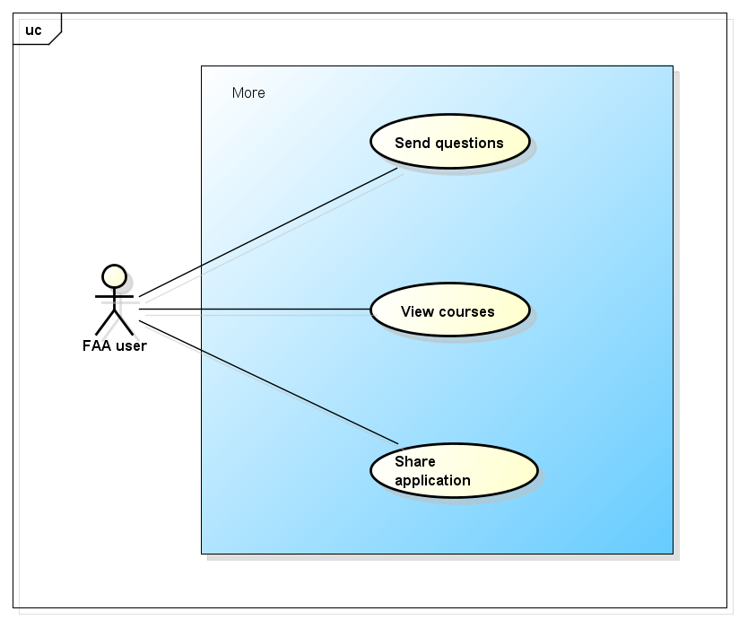

Figure -5: More use case

##### UC0013 - Send questions

|  |  |  |  |  |
| --- | --- | --- | --- | --- |
| **Use Case ID** | | UC0013 | **Version** | 1.1 |
| **Use Case Name** | | Send questions | | |
| **Created by:** | | AnhND | **Date Created:** | 24/09/2016 |
| **Primary Actor** | | FAA user | **Secondary Actor** |  |
| **Description:** | |  | | |
| **Preconditions:** | | 1. Install First Aid application 2. Customer launch application | | |
| **Trigger:** | |  | | |
| **Post conditions:** | |  | | |
| **Normal Flow** | | | | |
| **Step** | **Actor** | **Action** | | |
| 1 | Customer | Launch application | | |
| 2 | Customer |  | | |
| 3 | FAA |  | | |
| **Alternative Flows:** | | | | |
| **AT1** |  | | | |
| **Step** | **Actor** | **Action** | | |
|  |  |  | | |
| **Exceptions: N/A** | | | | |
| **Priority** | | High | | |
| **Frequency of Use:** | | High | | |
| **Business Rules:** | |  | | |
| **Other Information:** | | N/A | | |

Table 2- 19: Send question

##### UC0014 - View course

|  |  |  |  |  |
| --- | --- | --- | --- | --- |
| **Use Case ID** | | UC0014 | **Version** | 1.1 |
| **Use Case Name** | | View first aid course | | |
| **Created by:** | | AnhND | **Date Created:** | 24/09/2016 |
| **Primary Actor** | | FAA user | **Secondary Actor** |  |
| **Description:** | |  | | |
| **Preconditions:** | | 1. Install First Aid application 2. Customer launch application | | |
| **Trigger:** | |  | | |
| **Post conditions:** | |  | | |
| **Normal Flow** | | | | |
| **Step** | **Actor** | **Action** | | |
| 1 | Customer | Launch application | | |
| 2 | Customer |  | | |
| 3 | FAA |  | | |
| **Alternative Flows:** | | | | |
| **AT1** |  | | | |
| **Step** | **Actor** | **Action** | | |
|  |  |  | | |
| **Exceptions: N/A** | | | | |
| **Priority** | | High | | |
| **Frequency of Use:** | | High | | |
| **Business Rules:** | |  | | |
| **Other Information:** | | N/A | | |

Table 2- 19: View course

##### UC0015 - Share application

|  |  |  |  |  |
| --- | --- | --- | --- | --- |
| **Use Case ID** | | UC0015 | **Version** | 1.1 |
| **Use Case Name** | | Share application | | |
| **Created by:** | | AnhND | **Date Created:** | 24/09/2016 |
| **Primary Actor** | | FAA user | **Secondary Actor** |  |
| **Description:** | |  | | |
| **Preconditions:** | | 1. Install First Aid application 2. Customer launch application | | |
| **Trigger:** | |  | | |
| **Post conditions:** | |  | | |
| **Normal Flow** | | | | |
| **Step** | **Actor** | **Action** | | |
| 1 | Customer | Launch application | | |
| 2 | Customer |  | | |
| 3 | FAA |  | | |
| **Alternative Flows:** | | | | |
| **AT1** |  | | | |
| **Step** | **Actor** | **Action** | | |
|  |  |  | | |
| **Exceptions: N/A** | | | | |
| **Priority** | | High | | |
| **Frequency of Use:** | | High | | |
| **Business Rules:** | |  | | |
| **Other Information:** | | N/A | | |

Table 2- 19: Share application

#### Setting Module

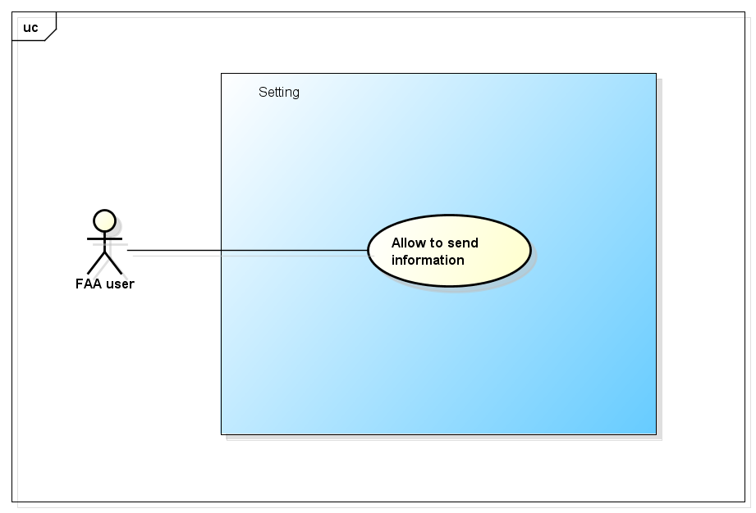

Figure -5: Setting use case

##### UC0016 - Allow to send information

|  |  |  |  |  |
| --- | --- | --- | --- | --- |
| **Use Case ID** | | UC0016 | **Version** | 1.1 |
| **Use Case Name** | | Allow to send information | | |
| **Created by:** | | AnhND | **Date Created:** | 24/09/2016 |
| **Primary Actor** | | FAA user | **Secondary Actor** |  |
| **Description:** | |  | | |
| **Preconditions:** | | 1. Install First Aid application 2. Customer launch application | | |
| **Trigger:** | |  | | |
| **Post conditions:** | |  | | |
| **Normal Flow** | | | | |
| **Step** | **Actor** | **Action** | | |
| 1 | Customer | Launch application | | |
| 2 | Customer |  | | |
| 3 | FAA |  | | |
| **Alternative Flows:** | | | | |
| **AT1** |  | | | |
| **Step** | **Actor** | **Action** | | |
|  |  |  | | |
| **Exceptions: N/A** | | | | |
| **Priority** | | High | | |
| **Frequency of Use:** | | High | | |
| **Business Rules:** | |  | | |
| **Other Information:** | | N/A | | |

Table 2- 19: Allow to send information

#### Information Module

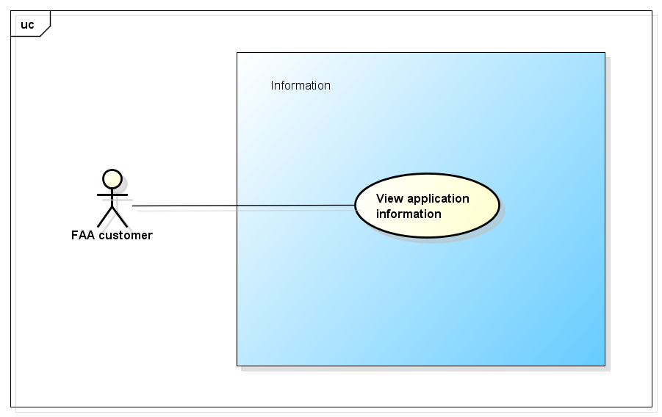

Figure -5: Information use case

##### UC0017 - View application information

|  |  |  |  |  |
| --- | --- | --- | --- | --- |
| **Use Case ID** | | UC0017 | **Version** | 1.1 |
| **Use Case Name** | | View application information | | |
| **Created by:** | | AnhND | **Date Created:** | 24/09/2016 |
| **Primary Actor** | | FAA user | **Secondary Actor** |  |
| **Description:** | |  | | |
| **Preconditions:** | | 1. Install First Aid application 2. Customer launch application | | |
| **Trigger:** | |  | | |
| **Post conditions:** | |  | | |
| **Normal Flow** | | | | |
| **Step** | **Actor** | **Action** | | |
| 1 | Customer | Launch application | | |
| 2 | Customer |  | | |
| 3 | FAA |  | | |
| **Alternative Flows:** | | | | |
| **AT1** |  | | | |
| **Step** | **Actor** | **Action** | | |
|  |  |  | | |
| **Exceptions: N/A** | | | | |
| **Priority** | | High | | |
| **Frequency of Use:** | | High | | |
| **Business Rules:** | |  | | |
| **Other Information:** | | N/A | | |

Table 2- 19: View application information

### **Dispatcher Application Function**

#### Common Module

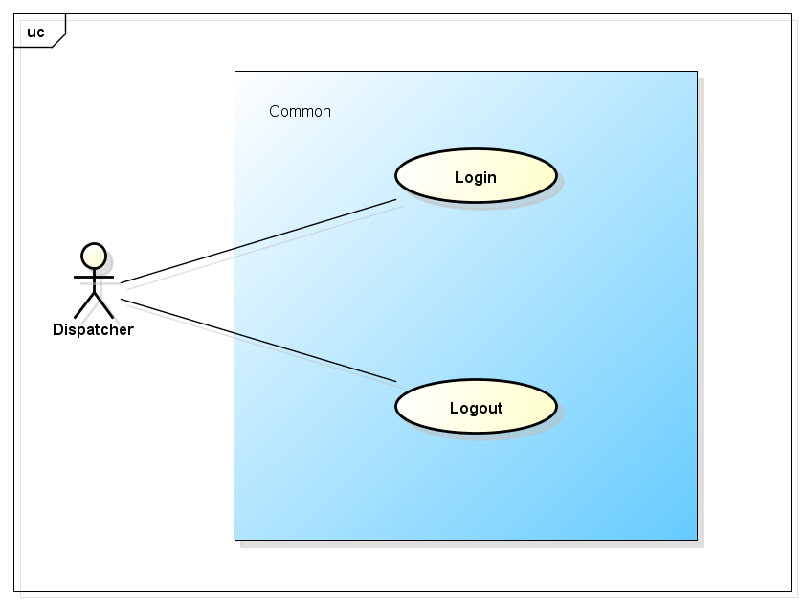

Figure -5: Common use case

##### UC0018 - Login

|  |  |  |  |  |
| --- | --- | --- | --- | --- |
| **Use Case ID** | | UC0018 | **Version** | 1.1 |
| **Use Case Name** | | Login | | |
| **Created by:** | | AnhND | **Date Created:** | 24/09/2016 |
| **Primary Actor** | | Dispatcher | **Secondary Actor** |  |
| **Description:** | |  | | |
| **Preconditions:** | |  | | |
| **Trigger:** | |  | | |
| **Post conditions:** | |  | | |
| **Normal Flow** | | | | |
| **Step** | **Actor** | **Action** | | |
| 1 | Customer | Launch application | | |
| 2 | Customer |  | | |
| 3 | FAA |  | | |
| **Alternative Flows:** | | | | |
| **AT1** |  | | | |
| **Step** | **Actor** | **Action** | | |
|  |  |  | | |
| **Exceptions: N/A** | | | | |
| **Priority** | | High | | |
| **Frequency of Use:** | | High | | |
| **Business Rules:** | |  | | |
| **Other Information:** | | N/A | | |

Table 2- 19: Login

##### UC0019 - Logout

|  |  |  |  |  |
| --- | --- | --- | --- | --- |
| **Use Case ID** | | UC0019 | **Version** | 1.1 |
| **Use Case Name** | | Logout | | |
| **Created by:** | | AnhND | **Date Created:** | 24/09/2016 |
| **Primary Actor** | | Dispatcher | **Secondary Actor** |  |
| **Description:** | |  | | |
| **Preconditions:** | |  | | |
| **Trigger:** | |  | | |
| **Post conditions:** | |  | | |
| **Normal Flow** | | | | |
| **Step** | **Actor** | **Action** | | |
| 1 | Customer | Launch application | | |
| 2 | Customer |  | | |
| 3 | FAA |  | | |
| **Alternative Flows:** | | | | |
| **AT1** |  | | | |
| **Step** | **Actor** | **Action** | | |
|  |  |  | | |
| **Exceptions: N/A** | | | | |
| **Priority** | | High | | |
| **Frequency of Use:** | | High | | |
| **Business Rules:** | |  | | |
| **Other Information:** | | N/A | | |

Table 2- 19: Logout

#### Dispatch Module

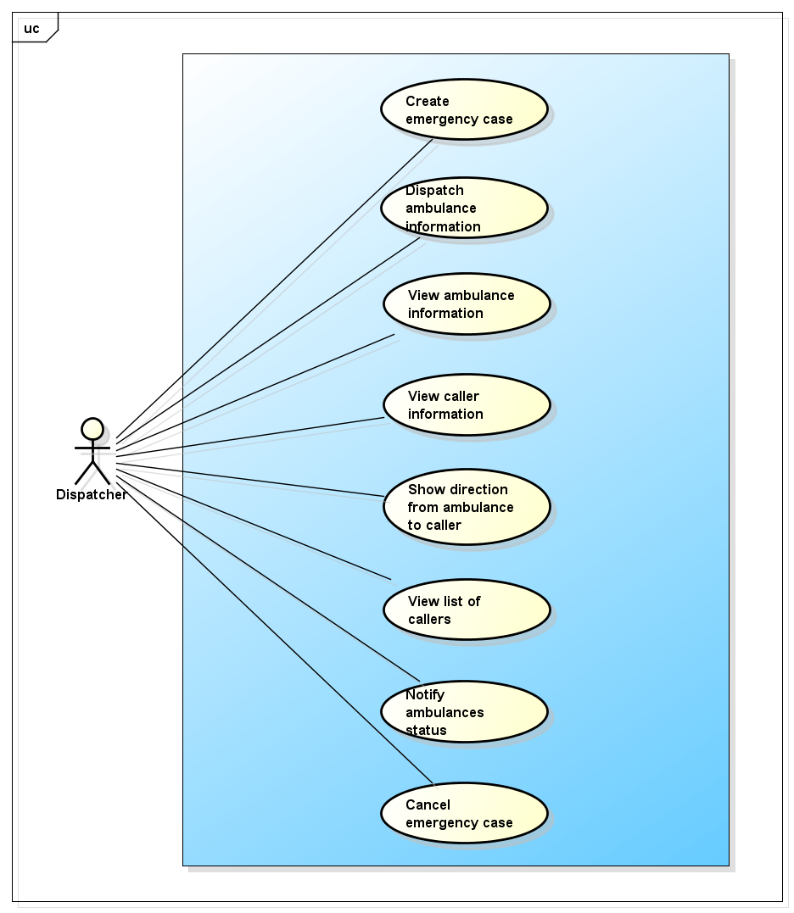

Figure -5: Dispatch use case

##### UC0020 - Create emergency case

|  |  |  |  |  |
| --- | --- | --- | --- | --- |
| **Use Case ID** | | UC0020 | **Version** | 1.1 |
| **Use Case Name** | | Create emergency case | | |
| **Created by:** | | AnhND | **Date Created:** | 24/09/2016 |
| **Primary Actor** | | Dispatcher | **Secondary Actor** |  |
| **Description:** | |  | | |
| **Preconditions:** | |  | | |
| **Trigger:** | |  | | |
| **Post conditions:** | |  | | |
| **Normal Flow** | | | | |
| **Step** | **Actor** | **Action** | | |
| 1 | Customer | Launch application | | |
| 2 | Customer |  | | |
| 3 | FAA |  | | |
| **Alternative Flows:** | | | | |
| **AT1** |  | | | |
| **Step** | **Actor** | **Action** | | |
|  |  |  | | |
| **Exceptions: N/A** | | | | |
| **Priority** | | High | | |
| **Frequency of Use:** | | High | | |
| **Business Rules:** | |  | | |
| **Other Information:** | | N/A | | |

Table 2- 19: Create emergency case

##### UC0021 - Dispatch ambulance information

|  |  |  |  |  |
| --- | --- | --- | --- | --- |
| **Use Case ID** | | UC0021 | **Version** | 1.1 |
| **Use Case Name** | | Dispatch ambulance information | | |
| **Created by:** | | AnhND | **Date Created:** | 24/09/2016 |
| **Primary Actor** | | Dispatcher | **Secondary Actor** |  |
| **Description:** | |  | | |
| **Preconditions:** | |  | | |
| **Trigger:** | |  | | |
| **Post conditions:** | |  | | |
| **Normal Flow** | | | | |
| **Step** | **Actor** | **Action** | | |
| 1 | Customer | Launch application | | |
| 2 | Customer |  | | |
| 3 | FAA |  | | |
| **Alternative Flows:** | | | | |
| **AT1** |  | | | |
| **Step** | **Actor** | **Action** | | |
|  |  |  | | |
| **Exceptions: N/A** | | | | |
| **Priority** | | High | | |
| **Frequency of Use:** | | High | | |
| **Business Rules:** | |  | | |
| **Other Information:** | | N/A | | |

Table 2- 19: Dispatch ambulance information

##### UC0022 - View ambulance information

|  |  |  |  |  |
| --- | --- | --- | --- | --- |
| **Use Case ID** | | UC0022 | **Version** | 1.1 |
| **Use Case Name** | | View ambulance information | | |
| **Created by:** | | AnhND | **Date Created:** | 24/09/2016 |
| **Primary Actor** | | Dispatcher | **Secondary Actor** |  |
| **Description:** | |  | | |
| **Preconditions:** | |  | | |
| **Trigger:** | |  | | |
| **Post conditions:** | |  | | |
| **Normal Flow** | | | | |
| **Step** | **Actor** | **Action** | | |
| 1 | Customer | Launch application | | |
| 2 | Customer |  | | |
| 3 | FAA |  | | |
| **Alternative Flows:** | | | | |
| **AT1** |  | | | |
| **Step** | **Actor** | **Action** | | |
|  |  |  | | |
| **Exceptions: N/A** | | | | |
| **Priority** | | High | | |
| **Frequency of Use:** | | High | | |
| **Business Rules:** | |  | | |
| **Other Information:** | | N/A | | |

Table 2- 19: View ambulance information

##### UC0023 - View caller information

|  |  |  |  |  |
| --- | --- | --- | --- | --- |
| **Use Case ID** | | UC0023 | **Version** | 1.1 |
| **Use Case Name** | | View caller information | | |
| **Created by:** | | AnhND | **Date Created:** | 24/09/2016 |
| **Primary Actor** | | Dispatcher | **Secondary Actor** |  |
| **Description:** | |  | | |
| **Preconditions:** | |  | | |
| **Trigger:** | |  | | |
| **Post conditions:** | |  | | |
| **Normal Flow** | | | | |
| **Step** | **Actor** | **Action** | | |
| 1 | Customer | Launch application | | |
| 2 | Customer |  | | |
| 3 | FAA |  | | |
| **Alternative Flows:** | | | | |
| **AT1** |  | | | |
| **Step** | **Actor** | **Action** | | |
|  |  |  | | |
| **Exceptions: N/A** | | | | |
| **Priority** | | High | | |
| **Frequency of Use:** | | High | | |
| **Business Rules:** | |  | | |
| **Other Information:** | | N/A | | |

Table 2- 19: View caller information

##### UC0024 - Show direction from ambulance to caller

|  |  |  |  |  |
| --- | --- | --- | --- | --- |
| **Use Case ID** | | UC0024 | **Version** | 1.1 |
| **Use Case Name** | | Show direction from ambulance to caller | | |
| **Created by:** | | AnhND | **Date Created:** | 24/09/2016 |
| **Primary Actor** | | Dispatcher | **Secondary Actor** |  |
| **Description:** | |  | | |
| **Preconditions:** | |  | | |
| **Trigger:** | |  | | |
| **Post conditions:** | |  | | |
| **Normal Flow** | | | | |
| **Step** | **Actor** | **Action** | | |
| 1 | Customer | Launch application | | |
| 2 | Customer |  | | |
| 3 | FAA |  | | |
| **Alternative Flows:** | | | | |
| **AT1** |  | | | |
| **Step** | **Actor** | **Action** | | |
|  |  |  | | |
| **Exceptions: N/A** | | | | |
| **Priority** | | High | | |
| **Frequency of Use:** | | High | | |
| **Business Rules:** | |  | | |
| **Other Information:** | | N/A | | |

Table 2- 19: Show direction from ambulance to caller

##### UC0025 - View list of callers

|  |  |  |  |  |
| --- | --- | --- | --- | --- |
| **Use Case ID** | | UC0025 | **Version** | 1.1 |
| **Use Case Name** | | View list of callers | | |
| **Created by:** | | AnhND | **Date Created:** | 24/09/2016 |
| **Primary Actor** | | Dispatcher | **Secondary Actor** |  |
| **Description:** | |  | | |
| **Preconditions:** | |  | | |
| **Trigger:** | |  | | |
| **Post conditions:** | |  | | |
| **Normal Flow** | | | | |
| **Step** | **Actor** | **Action** | | |
| 1 | Customer | Launch application | | |
| 2 | Customer |  | | |
| 3 | FAA |  | | |
| **Alternative Flows:** | | | | |
| **AT1** |  | | | |
| **Step** | **Actor** | **Action** | | |
|  |  |  | | |
| **Exceptions: N/A** | | | | |
| **Priority** | | High | | |
| **Frequency of Use:** | | High | | |
| **Business Rules:** | |  | | |
| **Other Information:** | | N/A | | |

Table 2- 19: View list of callers

##### UC0026 - Notify ambulances status

|  |  |  |  |  |
| --- | --- | --- | --- | --- |
| **Use Case ID** | | UC0026 | **Version** | 1.1 |
| **Use Case Name** | | Notify ambulances status | | |
| **Created by:** | | AnhND | **Date Created:** | 24/09/2016 |
| **Primary Actor** | | Dispatcher | **Secondary Actor** |  |
| **Description:** | |  | | |
| **Preconditions:** | |  | | |
| **Trigger:** | |  | | |
| **Post conditions:** | |  | | |
| **Normal Flow** | | | | |
| **Step** | **Actor** | **Action** | | |
| 1 | Customer | Launch application | | |
| 2 | Customer |  | | |
| 3 | FAA |  | | |
| **Alternative Flows:** | | | | |
| **AT1** |  | | | |
| **Step** | **Actor** | **Action** | | |
|  |  |  | | |
| **Exceptions: N/A** | | | | |
| **Priority** | | High | | |
| **Frequency of Use:** | | High | | |
| **Business Rules:** | |  | | |
| **Other Information:** | | N/A | | |

Table 2- 19: Notify ambulances status

##### UC0027 - Cancel emergency case

|  |  |  |  |  |
| --- | --- | --- | --- | --- |
| **Use Case ID** | | UC0027 | **Version** | 1.1 |
| **Use Case Name** | |  | | |
| **Created by:** | | AnhND | **Date Created:** | 24/09/2016 |
| **Primary Actor** | | Dispatcher | **Secondary Actor** |  |
| **Description:** | |  | | |
| **Preconditions:** | |  | | |
| **Trigger:** | |  | | |
| **Post conditions:** | |  | | |
| **Normal Flow** | | | | |
| **Step** | **Actor** | **Action** | | |
| 1 | Customer | Launch application | | |
| 2 | Customer |  | | |
| 3 | FAA |  | | |
| **Alternative Flows:** | | | | |
| **AT1** |  | | | |
| **Step** | **Actor** | **Action** | | |
|  |  |  | | |
| **Exceptions: N/A** | | | | |
| **Priority** | | High | | |
| **Frequency of Use:** | | High | | |
| **Business Rules:** | |  | | |
| **Other Information:** | | N/A | | |

Table 2- 19: Cancel emergency case

### **Ambulance Application Function**

#### Common Module

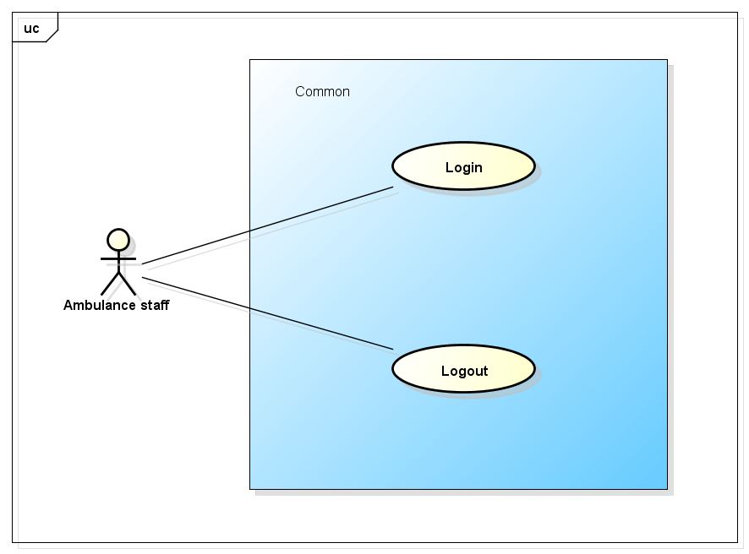

Figure -5: Common use case

##### UC0028 - Login

|  |  |  |  |  |
| --- | --- | --- | --- | --- |
| **Use Case ID** | | UC0029 | **Version** | 1.1 |
| **Use Case Name** | | Login | | |
| **Created by:** | | AnhND | **Date Created:** | 24/09/2016 |
| **Primary Actor** | |  | **Secondary Actor** |  |
| **Description:** | |  | | |
| **Preconditions:** | |  | | |
| **Trigger:** | |  | | |
| **Post conditions:** | |  | | |
| **Normal Flow** | | | | |
| **Step** | **Actor** | **Action** | | |
| 1 | Customer | Launch application | | |
| 2 | Customer |  | | |
| 3 | FAA |  | | |
| **Alternative Flows:** | | | | |
| **AT1** |  | | | |
| **Step** | **Actor** | **Action** | | |
|  |  |  | | |
| **Exceptions: N/A** | | | | |
| **Priority** | | High | | |
| **Frequency of Use:** | | High | | |
| **Business Rules:** | |  | | |
| **Other Information:** | | N/A | | |

Table 2- 19: Login

##### UC0029 - Logout

|  |  |  |  |  |
| --- | --- | --- | --- | --- |
| **Use Case ID** | | UC0030 | **Version** | 1.1 |
| **Use Case Name** | | Logout | | |
| **Created by:** | | AnhND | **Date Created:** | 24/09/2016 |
| **Primary Actor** | |  | **Secondary Actor** |  |
| **Description:** | |  | | |
| **Preconditions:** | |  | | |
| **Trigger:** | |  | | |
| **Post conditions:** | |  | | |
| **Normal Flow** | | | | |
| **Step** | **Actor** | **Action** | | |
| 1 | Customer | Launch application | | |
| 2 | Customer |  | | |
| 3 | FAA |  | | |
| **Alternative Flows:** | | | | |
| **AT1** |  | | | |
| **Step** | **Actor** | **Action** | | |
|  |  |  | | |
| **Exceptions: N/A** | | | | |
| **Priority** | | High | | |
| **Frequency of Use:** | | High | | |
| **Business Rules:** | |  | | |
| **Other Information:** | | N/A | | |

Table 2- 19: Logout

#### Task Module

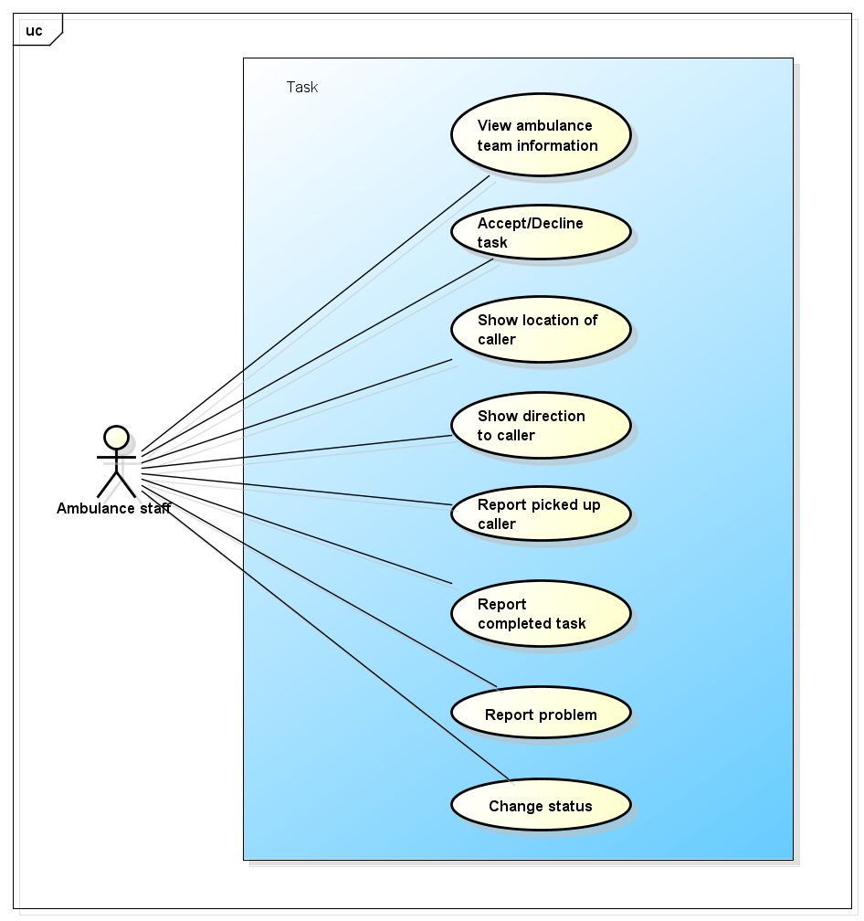

Figure -5: Task use case

##### UC0030 - View ambulance team information

|  |  |  |  |  |
| --- | --- | --- | --- | --- |
| **Use Case ID** | | UC0030 | **Version** | 1.1 |
| **Use Case Name** | | View ambulance team information | | |
| **Created by:** | | AnhND | **Date Created:** | 24/09/2016 |
| **Primary Actor** | |  | **Secondary Actor** |  |
| **Description:** | |  | | |
| **Preconditions:** | |  | | |
| **Trigger:** | |  | | |
| **Post conditions:** | |  | | |
| **Normal Flow** | | | | |
| **Step** | **Actor** | **Action** | | |
| 1 | Customer | Launch application | | |
| 2 | Customer |  | | |
| 3 | FAA |  | | |
| **Alternative Flows:** | | | | |
| **AT1** |  | | | |
| **Step** | **Actor** | **Action** | | |
|  |  |  | | |
| **Exceptions: N/A** | | | | |
| **Priority** | | High | | |
| **Frequency of Use:** | | High | | |
| **Business Rules:** | |  | | |
| **Other Information:** | | N/A | | |

Table 2- 19: View ambulance team information

##### UC0031 - Accept/Decline task

|  |  |  |  |  |
| --- | --- | --- | --- | --- |
| **Use Case ID** | | UC0031 | **Version** | 1.1 |
| **Use Case Name** | | Accept/Decline task | | |
| **Created by:** | | AnhND | **Date Created:** | 24/09/2016 |
| **Primary Actor** | |  | **Secondary Actor** |  |
| **Description:** | |  | | |
| **Preconditions:** | |  | | |
| **Trigger:** | |  | | |
| **Post conditions:** | |  | | |
| **Normal Flow** | | | | |
| **Step** | **Actor** | **Action** | | |
| 1 | Customer | Launch application | | |
| 2 | Customer |  | | |
| 3 | FAA |  | | |
| **Alternative Flows:** | | | | |
| **AT1** |  | | | |
| **Step** | **Actor** | **Action** | | |
|  |  |  | | |
| **Exceptions: N/A** | | | | |
| **Priority** | | High | | |
| **Frequency of Use:** | | High | | |
| **Business Rules:** | |  | | |
| **Other Information:** | | N/A | | |

Table 2- 19: Accept/Decline task

##### UC0032 - Show location of caller

|  |  |  |  |  |
| --- | --- | --- | --- | --- |
| **Use Case ID** | | UC0032 | **Version** | 1.1 |
| **Use Case Name** | | Show location of caller | | |
| **Created by:** | | AnhND | **Date Created:** | 24/09/2016 |
| **Primary Actor** | |  | **Secondary Actor** |  |
| **Description:** | |  | | |
| **Preconditions:** | |  | | |
| **Trigger:** | |  | | |
| **Post conditions:** | |  | | |
| **Normal Flow** | | | | |
| **Step** | **Actor** | **Action** | | |
| 1 | Customer | Launch application | | |
| 2 | Customer |  | | |
| 3 | FAA |  | | |
| **Alternative Flows:** | | | | |
| **AT1** |  | | | |
| **Step** | **Actor** | **Action** | | |
|  |  |  | | |
| **Exceptions: N/A** | | | | |
| **Priority** | | High | | |
| **Frequency of Use:** | | High | | |
| **Business Rules:** | |  | | |
| **Other Information:** | | N/A | | |

Table 2- 19: Show location of caller

##### UC0033 - Show direction to caller

|  |  |  |  |  |
| --- | --- | --- | --- | --- |
| **Use Case ID** | | UC0033 | **Version** | 1.1 |
| **Use Case Name** | | Show direction to caller | | |
| **Created by:** | | AnhND | **Date Created:** | 24/09/2016 |
| **Primary Actor** | |  | **Secondary Actor** |  |
| **Description:** | |  | | |
| **Preconditions:** | |  | | |
| **Trigger:** | |  | | |
| **Post conditions:** | |  | | |
| **Normal Flow** | | | | |
| **Step** | **Actor** | **Action** | | |
| 1 | Customer | Launch application | | |
| 2 | Customer |  | | |
| 3 | FAA |  | | |
| **Alternative Flows:** | | | | |
| **AT1** |  | | | |
| **Step** | **Actor** | **Action** | | |
|  |  |  | | |
| **Exceptions: N/A** | | | | |
| **Priority** | | High | | |
| **Frequency of Use:** | | High | | |
| **Business Rules:** | |  | | |
| **Other Information:** | | N/A | | |

Table 2- 19: Show direction to caller

##### UC0034 - Report picked up caller

|  |  |  |  |  |
| --- | --- | --- | --- | --- |
| **Use Case ID** | | UC0034 | **Version** | 1.1 |
| **Use Case Name** | | Report picked up caller | | |
| **Created by:** | | AnhND | **Date Created:** | 24/09/2016 |
| **Primary Actor** | |  | **Secondary Actor** |  |
| **Description:** | |  | | |
| **Preconditions:** | |  | | |
| **Trigger:** | |  | | |
| **Post conditions:** | |  | | |
| **Normal Flow** | | | | |
| **Step** | **Actor** | **Action** | | |
| 1 | Customer | Launch application | | |
| 2 | Customer |  | | |
| 3 | FAA |  | | |
| **Alternative Flows:** | | | | |
| **AT1** |  | | | |
| **Step** | **Actor** | **Action** | | |
|  |  |  | | |
| **Exceptions: N/A** | | | | |
| **Priority** | | High | | |
| **Frequency of Use:** | | High | | |
| **Business Rules:** | |  | | |
| **Other Information:** | | N/A | | |

Table 2- 19: Report picked up caller

##### UC0035 - Report completed task

|  |  |  |  |  |
| --- | --- | --- | --- | --- |
| **Use Case ID** | | UC0035 | **Version** | 1.1 |
| **Use Case Name** | | Report completed task | | |
| **Created by:** | | AnhND | **Date Created:** | 24/09/2016 |
| **Primary Actor** | |  | **Secondary Actor** |  |
| **Description:** | |  | | |
| **Preconditions:** | |  | | |
| **Trigger:** | |  | | |
| **Post conditions:** | |  | | |
| **Normal Flow** | | | | |
| **Step** | **Actor** | **Action** | | |
| 1 | Customer | Launch application | | |
| 2 | Customer |  | | |
| 3 | FAA |  | | |
| **Alternative Flows:** | | | | |
| **AT1** |  | | | |
| **Step** | **Actor** | **Action** | | |
|  |  |  | | |
| **Exceptions: N/A** | | | | |
| **Priority** | | High | | |
| **Frequency of Use:** | | High | | |
| **Business Rules:** | |  | | |
| **Other Information:** | | N/A | | |

Table 2- 19: Report completed task

##### UC0036 - Report problem

|  |  |  |  |  |
| --- | --- | --- | --- | --- |
| **Use Case ID** | | UC0036 | **Version** | 1.1 |
| **Use Case Name** | | Report problem | | |
| **Created by:** | | AnhND | **Date Created:** | 24/09/2016 |
| **Primary Actor** | |  | **Secondary Actor** |  |
| **Description:** | |  | | |
| **Preconditions:** | |  | | |
| **Trigger:** | |  | | |
| **Post conditions:** | |  | | |
| **Normal Flow** | | | | |
| **Step** | **Actor** | **Action** | | |
| 1 | Customer | Launch application | | |
| 2 | Customer |  | | |
| 3 | FAA |  | | |
| **Alternative Flows:** | | | | |
| **AT1** |  | | | |
| **Step** | **Actor** | **Action** | | |
|  |  |  | | |
| **Exceptions: N/A** | | | | |
| **Priority** | | High | | |
| **Frequency of Use:** | | High | | |
| **Business Rules:** | |  | | |
| **Other Information:** | | N/A | | |

Table 2- 19: Report problem

##### UC0037 - Change status

|  |  |  |  |  |
| --- | --- | --- | --- | --- |
| **Use Case ID** | | UC0037 | **Version** | 1.1 |
| **Use Case Name** | | Change status | | |
| **Created by:** | | AnhND | **Date Created:** | 24/09/2016 |
| **Primary Actor** | |  | **Secondary Actor** |  |
| **Description:** | |  | | |
| **Preconditions:** | |  | | |
| **Trigger:** | |  | | |
| **Post conditions:** | |  | | |
| **Normal Flow** | | | | |
| **Step** | **Actor** | **Action** | | |
| 1 | Customer | Launch application | | |
| 2 | Customer |  | | |
| 3 | FAA |  | | |
| **Alternative Flows:** | | | | |
| **AT1** |  | | | |
| **Step** | **Actor** | **Action** | | |
|  |  |  | | |
| **Exceptions: N/A** | | | | |
| **Priority** | | High | | |
| **Frequency of Use:** | | High | | |
| **Business Rules:** | |  | | |
| **Other Information:** | | N/A | | |

Table 2- 19: Change status

### **Admin/Expert Application Function**

#### Common Module

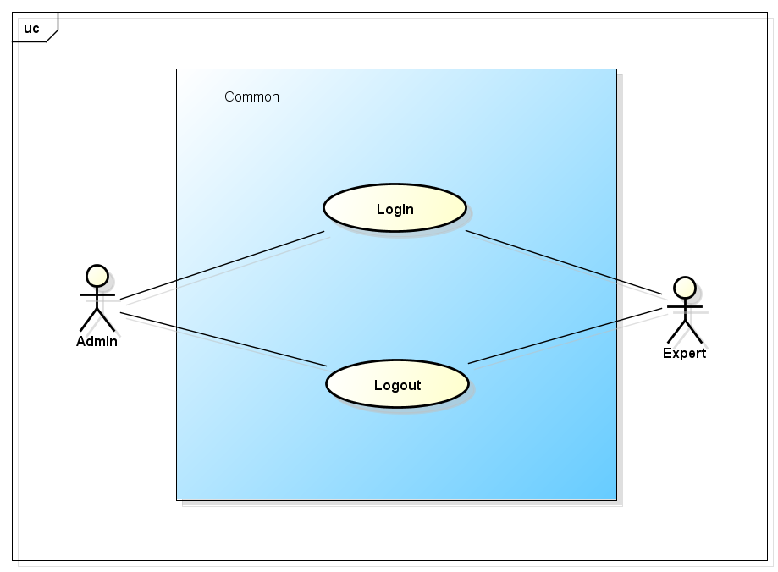

Figure -5: Common use case

##### UC0038 - Login

|  |  |  |  |  |
| --- | --- | --- | --- | --- |
| **Use Case ID** | | UC0038 | **Version** | 1.1 |
| **Use Case Name** | | Login | | |
| **Created by:** | | AnhND | **Date Created:** | 24/09/2016 |
| **Primary Actor** | | Admin/Expert | **Secondary Actor** |  |
| **Description:** | |  | | |
| **Preconditions:** | |  | | |
| **Trigger:** | |  | | |
| **Post conditions:** | |  | | |
| **Normal Flow** | | | | |
| **Step** | **Actor** | **Action** | | |
| 1 | Customer | Launch application | | |
| 2 | Customer |  | | |
| 3 | FAA |  | | |
| **Alternative Flows:** | | | | |
| **AT1** |  | | | |
| **Step** | **Actor** | **Action** | | |
|  |  |  | | |
| **Exceptions: N/A** | | | | |
| **Priority** | | High | | |
| **Frequency of Use:** | | High | | |
| **Business Rules:** | |  | | |
| **Other Information:** | | N/A | | |

Table 2- 19: Login

##### UC0039 - Logout

|  |  |  |  |  |
| --- | --- | --- | --- | --- |
| **Use Case ID** | | UC0039 | **Version** | 1.1 |
| **Use Case Name** | | Logout | | |
| **Created by:** | | AnhND | **Date Created:** | 24/09/2016 |
| **Primary Actor** | | Admin/Expert | **Secondary Actor** |  |
| **Description:** | |  | | |
| **Preconditions:** | |  | | |
| **Trigger:** | |  | | |
| **Post conditions:** | |  | | |
| **Normal Flow** | | | | |
| **Step** | **Actor** | **Action** | | |
| 1 | Customer | Launch application | | |
| 2 | Customer |  | | |
| 3 | FAA |  | | |
| **Alternative Flows:** | | | | |
| **AT1** |  | | | |
| **Step** | **Actor** | **Action** | | |
|  |  |  | | |
| **Exceptions: N/A** | | | | |
| **Priority** | | High | | |
| **Frequency of Use:** | | High | | |
| **Business Rules:** | |  | | |
| **Other Information:** | | N/A | | |

Table 2- 19: Logout

#### Manage user's account Module

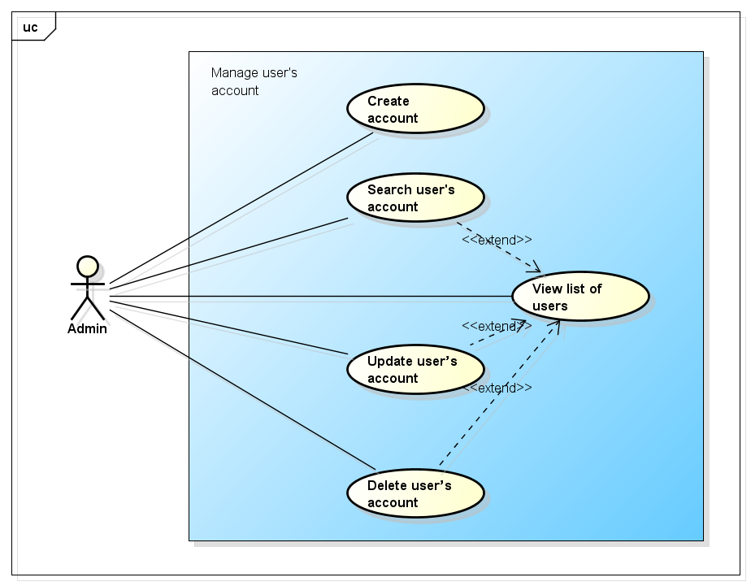

Figure -5: Manage user's account use case

##### UC0040 - Create account

|  |  |  |  |  |
| --- | --- | --- | --- | --- |
| **Use Case ID** | | UC0040 | **Version** | 1.1 |
| **Use Case Name** | | Create account | | |
| **Created by:** | | AnhND | **Date Created:** | 24/09/2016 |
| **Primary Actor** | | Admin | **Secondary Actor** |  |
| **Description:** | |  | | |
| **Preconditions:** | |  | | |
| **Trigger:** | |  | | |
| **Post conditions:** | |  | | |
| **Normal Flow** | | | | |
| **Step** | **Actor** | **Action** | | |
| 1 |  |  | | |
| 2 |  |  | | |
| 3 |  |  | | |
| **Alternative Flows:** | | | | |
| **AT1** |  | | | |
| **Step** | **Actor** | **Action** | | |
|  |  |  | | |
| **Exceptions: N/A** | | | | |
| **Priority** | | High | | |
| **Frequency of Use:** | | High | | |
| **Business Rules:** | |  | | |
| **Other Information:** | | N/A | | |

Table 2- 19: Create account

##### UC0041 - View list of users

|  |  |  |  |  |
| --- | --- | --- | --- | --- |
| **Use Case ID** | | UC0041 | **Version** | 1.1 |
| **Use Case Name** | | View list of users | | |
| **Created by:** | | AnhND | **Date Created:** | 24/09/2016 |
| **Primary Actor** | | Admin | **Secondary Actor** |  |
| **Description:** | |  | | |
| **Preconditions:** | |  | | |
| **Trigger:** | |  | | |
| **Post conditions:** | |  | | |
| **Normal Flow** | | | | |
| **Step** | **Actor** | **Action** | | |
| 1 |  |  | | |
| 2 |  |  | | |
| 3 |  |  | | |
| **Alternative Flows:** | | | | |
| **AT1** |  | | | |
| **Step** | **Actor** | **Action** | | |
|  |  |  | | |
| **Exceptions: N/A** | | | | |
| **Priority** | | High | | |
| **Frequency of Use:** | | High | | |
| **Business Rules:** | |  | | |
| **Other Information:** | | N/A | | |

Table 2- 19: View list of users

##### UC0042 - Search user's account

|  |  |  |  |  |
| --- | --- | --- | --- | --- |
| **Use Case ID** | | UC0042 | **Version** | 1.1 |
| **Use Case Name** | | Search user's account | | |
| **Created by:** | | AnhND | **Date Created:** | 24/09/2016 |
| **Primary Actor** | | Admin | **Secondary Actor** |  |
| **Description:** | |  | | |
| **Preconditions:** | |  | | |
| **Trigger:** | |  | | |
| **Post conditions:** | |  | | |
| **Normal Flow** | | | | |
| **Step** | **Actor** | **Action** | | |
| 1 |  |  | | |
| 2 |  |  | | |
| 3 |  |  | | |
| **Alternative Flows:** | | | | |
| **AT1** |  | | | |
| **Step** | **Actor** | **Action** | | |
|  |  |  | | |
| **Exceptions: N/A** | | | | |
| **Priority** | | High | | |
| **Frequency of Use:** | | High | | |
| **Business Rules:** | |  | | |
| **Other Information:** | | N/A | | |

Table 2- 19: Search user's account

##### UC0043 - Update user’s account

|  |  |  |  |  |
| --- | --- | --- | --- | --- |
| **Use Case ID** | | UC0043 | **Version** | 1.1 |
| **Use Case Name** | | Update user's account | | |
| **Created by:** | | AnhND | **Date Created:** | 24/09/2016 |
| **Primary Actor** | | Admin | **Secondary Actor** |  |
| **Description:** | |  | | |
| **Preconditions:** | |  | | |
| **Trigger:** | |  | | |
| **Post conditions:** | |  | | |
| **Normal Flow** | | | | |
| **Step** | **Actor** | **Action** | | |
| 1 |  |  | | |
| 2 |  |  | | |
| 3 |  |  | | |
| **Alternative Flows:** | | | | |
| **AT1** |  | | | |
| **Step** | **Actor** | **Action** | | |
|  |  |  | | |
| **Exceptions: N/A** | | | | |
| **Priority** | | High | | |
| **Frequency of Use:** | | High | | |
| **Business Rules:** | |  | | |
| **Other Information:** | | N/A | | |

Table 2- 19: Update user's account

##### UC0044 - Delete user’s account

|  |  |  |  |  |
| --- | --- | --- | --- | --- |
| **Use Case ID** | | UC0044 | **Version** | 1.1 |
| **Use Case Name** | | Delete user’s account | | |
| **Created by:** | | AnhND | **Date Created:** | 24/09/2016 |
| **Primary Actor** | | Admin | **Secondary Actor** |  |
| **Description:** | |  | | |
| **Preconditions:** | |  | | |
| **Trigger:** | |  | | |
| **Post conditions:** | |  | | |
| **Normal Flow** | | | | |
| **Step** | **Actor** | **Action** | | |
| 1 |  |  | | |
| 2 |  |  | | |
| 3 |  |  | | |
| **Alternative Flows:** | | | | |
| **AT1** |  | | | |
| **Step** | **Actor** | **Action** | | |
|  |  |  | | |
| **Exceptions: N/A** | | | | |
| **Priority** | | High | | |
| **Frequency of Use:** | | High | | |
| **Business Rules:** | |  | | |
| **Other Information:** | | N/A | | |

Table 2- 19: Delete user’s account

#### Manage Q&A Module

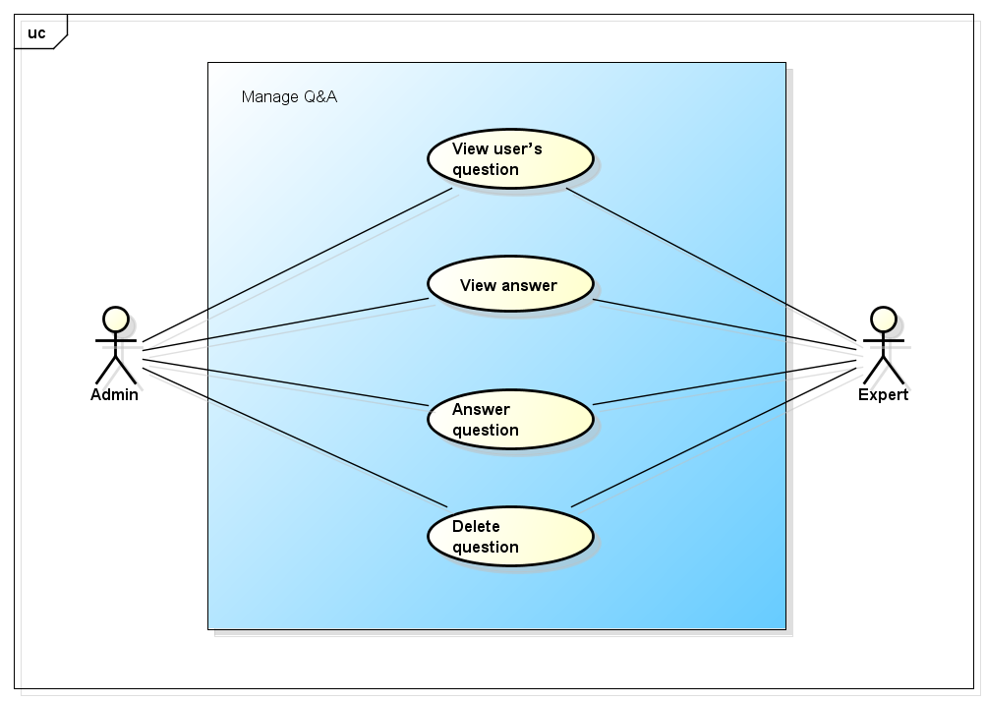

Figure -5: Manage Q&A use case

##### UC0045 - View user’s question

|  |  |  |  |  |
| --- | --- | --- | --- | --- |
| **Use Case ID** | | UC0045 | **Version** | 1.1 |
| **Use Case Name** | | View user’s question | | |
| **Created by:** | | AnhND | **Date Created:** | 24/09/2016 |
| **Primary Actor** | | Admin/Expert | **Secondary Actor** |  |
| **Description:** | |  | | |
| **Preconditions:** | |  | | |
| **Trigger:** | |  | | |
| **Post conditions:** | |  | | |
| **Normal Flow** | | | | |
| **Step** | **Actor** | **Action** | | |
| 1 |  |  | | |
| 2 |  |  | | |
| 3 |  |  | | |
| **Alternative Flows:** | | | | |
| **AT1** |  | | | |
| **Step** | **Actor** | **Action** | | |
|  |  |  | | |
| **Exceptions: N/A** | | | | |
| **Priority** | | High | | |
| **Frequency of Use:** | | High | | |
| **Business Rules:** | |  | | |
| **Other Information:** | | N/A | | |

Table 2- 19: View user’s question

##### UC0046 - View answer

|  |  |  |  |  |
| --- | --- | --- | --- | --- |
| **Use Case ID** | | UC0046 | **Version** | 1.1 |
| **Use Case Name** | | View answer | | |
| **Created by:** | | AnhND | **Date Created:** | 24/09/2016 |
| **Primary Actor** | | Admin/Expert | **Secondary Actor** |  |
| **Description:** | |  | | |
| **Preconditions:** | |  | | |
| **Trigger:** | |  | | |
| **Post conditions:** | |  | | |
| **Normal Flow** | | | | |
| **Step** | **Actor** | **Action** | | |
| 1 |  |  | | |
| 2 |  |  | | |
| 3 |  |  | | |
| **Alternative Flows:** | | | | |
| **AT1** |  | | | |
| **Step** | **Actor** | **Action** | | |
|  |  |  | | |
| **Exceptions: N/A** | | | | |
| **Priority** | | High | | |
| **Frequency of Use:** | | High | | |
| **Business Rules:** | |  | | |
| **Other Information:** | | N/A | | |

Table 2- 19: View answer

##### UC0047 - Answer question

|  |  |  |  |  |
| --- | --- | --- | --- | --- |
| **Use Case ID** | | UC0047 | **Version** | 1.1 |
| **Use Case Name** | | Answer question | | |
| **Created by:** | | AnhND | **Date Created:** | 24/09/2016 |
| **Primary Actor** | | Admin/Expert | **Secondary Actor** |  |
| **Description:** | |  | | |
| **Preconditions:** | |  | | |
| **Trigger:** | |  | | |
| **Post conditions:** | |  | | |
| **Normal Flow** | | | | |
| **Step** | **Actor** | **Action** | | |
| 1 |  |  | | |
| 2 |  |  | | |
| 3 |  |  | | |
| **Alternative Flows:** | | | | |
| **AT1** |  | | | |
| **Step** | **Actor** | **Action** | | |
|  |  |  | | |
| **Exceptions: N/A** | | | | |
| **Priority** | | High | | |
| **Frequency of Use:** | | High | | |
| **Business Rules:** | |  | | |
| **Other Information:** | | N/A | | |

Table 2- 19: Answer question

##### UC0048 - Delete question

|  |  |  |  |  |
| --- | --- | --- | --- | --- |
| **Use Case ID** | | UC0048 | **Version** | 1.1 |
| **Use Case Name** | | Delete question | | |
| **Created by:** | | AnhND | **Date Created:** | 24/09/2016 |
| **Primary Actor** | | Admin/Expert | **Secondary Actor** |  |
| **Description:** | |  | | |
| **Preconditions:** | |  | | |
| **Trigger:** | |  | | |
| **Post conditions:** | |  | | |
| **Normal Flow** | | | | |
| **Step** | **Actor** | **Action** | | |
| 1 |  |  | | |
| 2 |  |  | | |
| 3 |  |  | | |
| **Alternative Flows:** | | | | |
| **AT1** |  | | | |
| **Step** | **Actor** | **Action** | | |
|  |  |  | | |
| **Exceptions: N/A** | | | | |
| **Priority** | | High | | |
| **Frequency of Use:** | | High | | |
| **Business Rules:** | |  | | |
| **Other Information:** | | N/A | | |

Table 2- 19: Delete question

#### Manage injury Module

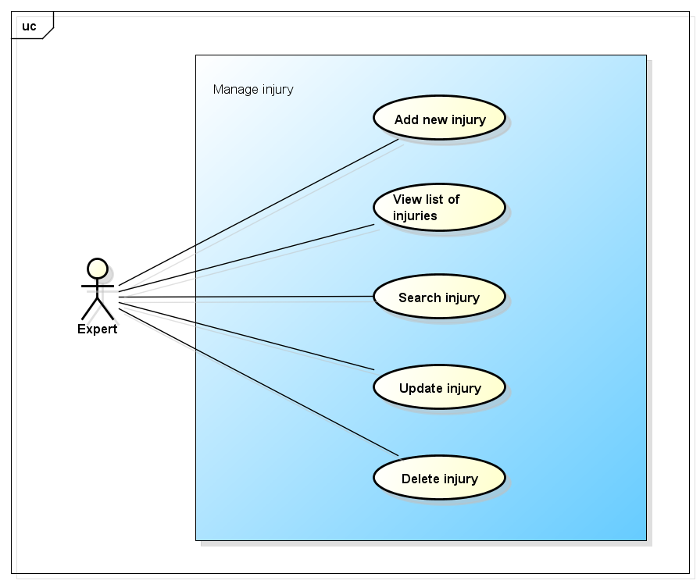

Figure -5: Manage injury use case

##### UC0049 - Add new injury

|  |  |  |  |  |
| --- | --- | --- | --- | --- |
| **Use Case ID** | | UC0049 | **Version** | 1.1 |
| **Use Case Name** | | Add new injury | | |
| **Created by:** | | AnhND | **Date Created:** | 24/09/2016 |
| **Primary Actor** | | Expert | **Secondary Actor** |  |
| **Description:** | |  | | |
| **Preconditions:** | |  | | |
| **Trigger:** | |  | | |
| **Post conditions:** | |  | | |
| **Normal Flow** | | | | |
| **Step** | **Actor** | **Action** | | |
| 1 |  |  | | |
| 2 |  |  | | |
| 3 |  |  | | |
| **Alternative Flows:** | | | | |
| **AT1** |  | | | |
| **Step** | **Actor** | **Action** | | |
|  |  |  | | |
| **Exceptions: N/A** | | | | |
| **Priority** | | High | | |
| **Frequency of Use:** | | High | | |
| **Business Rules:** | |  | | |
| **Other Information:** | | N/A | | |

Table 2- 19: Add new injury

##### UC0050 - View list of injuries

|  |  |  |  |  |
| --- | --- | --- | --- | --- |
| **Use Case ID** | | UC0050 | **Version** | 1.1 |
| **Use Case Name** | | View list of injuries | | |
| **Created by:** | | AnhND | **Date Created:** | 24/09/2016 |
| **Primary Actor** | | Expert | **Secondary Actor** |  |
| **Description:** | |  | | |
| **Preconditions:** | |  | | |
| **Trigger:** | |  | | |
| **Post conditions:** | |  | | |
| **Normal Flow** | | | | |
| **Step** | **Actor** | **Action** | | |
| 1 |  |  | | |
| 2 |  |  | | |
| 3 |  |  | | |
| **Alternative Flows:** | | | | |
| **AT1** |  | | | |
| **Step** | **Actor** | **Action** | | |
|  |  |  | | |
| **Exceptions: N/A** | | | | |
| **Priority** | | High | | |
| **Frequency of Use:** | | High | | |
| **Business Rules:** | |  | | |
| **Other Information:** | | N/A | | |

Table 2- 19: View list of injuries

##### UC0051 - Search injury

|  |  |  |  |  |
| --- | --- | --- | --- | --- |
| **Use Case ID** | | UC0051 | **Version** | 1.1 |
| **Use Case Name** | | Search injury | | |
| **Created by:** | | AnhND | **Date Created:** | 24/09/2016 |
| **Primary Actor** | | Expert | **Secondary Actor** |  |
| **Description:** | |  | | |
| **Preconditions:** | |  | | |
| **Trigger:** | |  | | |
| **Post conditions:** | |  | | |
| **Normal Flow** | | | | |
| **Step** | **Actor** | **Action** | | |
| 1 |  |  | | |
| 2 |  |  | | |
| 3 |  |  | | |
| **Alternative Flows:** | | | | |
| **AT1** |  | | | |
| **Step** | **Actor** | **Action** | | |
|  |  |  | | |
| **Exceptions: N/A** | | | | |
| **Priority** | | High | | |
| **Frequency of Use:** | | High | | |
| **Business Rules:** | |  | | |
| **Other Information:** | | N/A | | |

Table 2- 19: Search injury

##### UC0052 - Update injury

|  |  |  |  |  |
| --- | --- | --- | --- | --- |
| **Use Case ID** | | UC0052 | **Version** | 1.1 |
| **Use Case Name** | | Update injury | | |
| **Created by:** | | AnhND | **Date Created:** | 24/09/2016 |
| **Primary Actor** | | Expert | **Secondary Actor** |  |
| **Description:** | |  | | |
| **Preconditions:** | |  | | |
| **Trigger:** | |  | | |
| **Post conditions:** | |  | | |
| **Normal Flow** | | | | |
| **Step** | **Actor** | **Action** | | |
| 1 |  |  | | |
| 2 |  |  | | |
| 3 |  |  | | |
| **Alternative Flows:** | | | | |
| **AT1** |  | | | |
| **Step** | **Actor** | **Action** | | |
|  |  |  | | |
| **Exceptions: N/A** | | | | |
| **Priority** | | High | | |
| **Frequency of Use:** | | High | | |
| **Business Rules:** | |  | | |
| **Other Information:** | | N/A | | |

Table 2- 19: Update injury

##### UC0053 - Delete injury

|  |  |  |  |  |
| --- | --- | --- | --- | --- |
| **Use Case ID** | | UC0053 | **Version** | 1.1 |
| **Use Case Name** | | Delete injury | | |
| **Created by:** | | AnhND | **Date Created:** | 24/09/2016 |
| **Primary Actor** | | Expert | **Secondary Actor** |  |
| **Description:** | |  | | |
| **Preconditions:** | |  | | |
| **Trigger:** | |  | | |
| **Post conditions:** | |  | | |
| **Normal Flow** | | | | |
| **Step** | **Actor** | **Action** | | |
| 1 |  |  | | |
| 2 |  |  | | |
| 3 |  |  | | |
| **Alternative Flows:** | | | | |
| **AT1** |  | | | |
| **Step** | **Actor** | **Action** | | |
|  |  |  | | |
| **Exceptions: N/A** | | | | |
| **Priority** | | High | | |
| **Frequency of Use:** | | High | | |
| **Business Rules:** | |  | | |
| **Other Information:** | | N/A | | |

Table 2- 19: Delete injury

# **NON-FUNCTIONAL SPECIFICATION**

## **Reliability**

* + Mean time between failures: The mean time between each failure is expected to be about 480 hours of using.
  + The maximum bugs per function are 2 bugs/a function when user uses software within 2 months. The average number of bugs in the software during system testing is about to be around 1 bugs/KLOC.
  + The database must be backed up daily and can be recovered if necessary.

## **Performance Requirements**

### **Availability**

The application must be available 95% of time. Users can access to it everywhere from their

Web browser with internet connection.

### **Response time**

In term of response time, waiting time of processing will be 2 to 5 seconds; time to process any functions will not exceed 7 seconds.

## **Maintainability**

* + **Coding standards and naming conventions:**

**-** Output of the project must include coding standards and naming conventions documentations. Implementation code must be easy to maintain.

- If some components are reused, the documentations of those components must also be included.

* + **Design:** The design of the system must be loosely coupled that chances on some module will not affect others.
  + **Logging:**

**-** All the errors should be logged, supporting for bug fixing and maintenance.

- All strange or sensitive situations should also be logged.

* + **Mean time to repair:** Immediately when Administrator finds out problem or website is attacked/ hacked by someone. Average 1 day.

## **Usability**

Usability Requirements support the following from the perspective of its primary users:

* + **Efficiency of use:** user can complete each function in less than 12 actions
  + **Intuitiveness:** User can understand approximately 90% help/ error messages

## **Security Requirements**

In order to avoid unwanted access by strangers, the security implemented in various ways:

* + **User authorize**: Each function must be distributed system access and manipulate the individual parts. To edit information, user must declare their username and password before the operation. Functions will be show after users login dependencies user’s role and permission of each user.
  + **Manage Data Layer**: Only Administrator can modify database system.

## **Hardware/Software Requirements**

* + **Hardware requirement:**

**- Server:** Web service 2013, IIS8

**- Client:** PC/Laptop (window 7, window 8)

* + **Software requirements:**

**-** Web browser (Chrome 40.0, Firefox 30.0) with internet connection.

**-** Android 5.0 or higher.